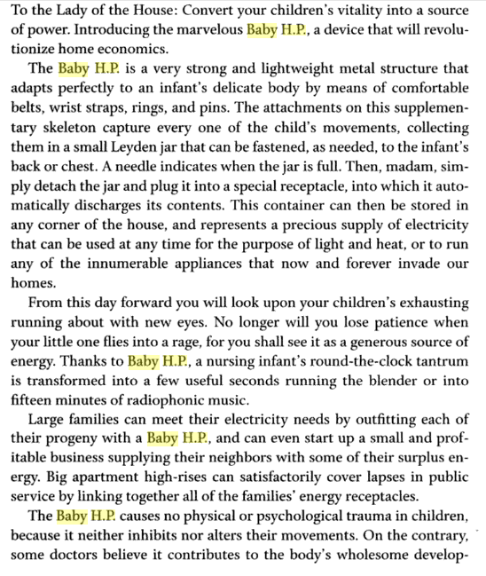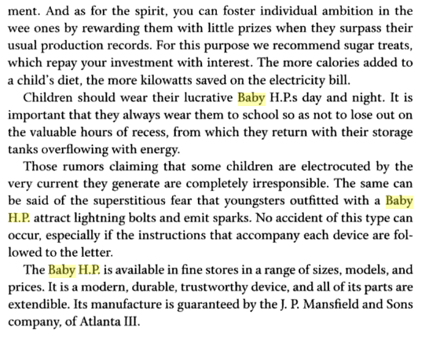

* What is the definition of satire?

____________________________________________________________________________________________________________

* What is Arreola criticizing?

________________________________________________________________________________________________________________________________________________________________________________________________________________________________________________________________________________________________

* Compare/Contrast “Baby HP” with Swift’s “Modest Proposal”

____________________________________________________________________________________________________________________________________________________________________________________________________________________________________________________________________________________________________________________________________________________________________________________________________________