Week 15 | 15.1 | 15.2 | 15.3 | 15.4 | 15.5
Dec 11-15 | Simulation  Reading time | Intro;  Essential Qs | Discuss Ch 2 | Holiday Concerts | Discuss Ch 3
 | HW: Read Ch 1 | HW: Read Ch 2 | HW: Read Ch 3 | HW: Read Ch 3 | HW: Read Ch 4
Week 16 | 16.1 | 16.2 | 16.3 | Break | Break
Dec 18-20 | Discuss 4 | Discuss 5  Vocab Quiz 1-5 | Writing
 | HW: Read Ch 5 | HW: Read Ch 6-7 | HW: Read Ch 6-7
Week 17 | Break | 17.1 | 17.2 | 17.3 | 17.4
Jan 2-5 |  | Discuss Ch 6-7 | Writing | Discuss Ch 8 | Vocab Quiz 6-9  Discuss Ch 9
 |  | HW: Read Ch 8 | HW: Read Ch 8 | HW: Read Ch 9 | HW: Read Ch 10-11
Week 18 | 18.1 | 18.2 | 18.3 | 18.4 | 18.5
Jan 8-12 | Discuss Ch 10 | Discuss Ch 10-11 | Discuss Ch 11 | Vocab Quiz 10-12  Discuss Ch 12 | Socratic Seminar
 | HW: Read Ch 10-11 | HW: Read Ch 12 | HW: Read Ch 12 | HW: Prep for Socratic Seminar | HW: None
Lord of the Flies - Calendar
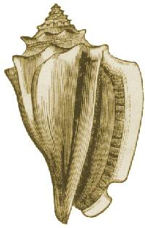

Quizzes [Process]: We will have occasional reading quizzes to test your comprehension as well as to keep you accountable for reading.

Vocabulary [Process]: We will have three vocabulary lists; each will require an assignment of your choosing and a quiz.

In Class Participation [Process]: We will have a variety of small activities and assignments done in class to help us process this novel. This includes “practice seminars” leading to your culminating seminar. You will be given credit based on your participation.

Journals [Participation]: As always.

Text Analysis [Writing]: You will write one short text analysis paper to continue working on essay-writing skills.

Socratic Seminar [Culminating]: I will assess your comprehension and depth of knowledge on this novel through a student-led discussion.

