G10-19-20 - Movements of Literature Graphic Organizer Name_________________________Class____#_____
-ISM | Enlightenment | Romanticism | Realism | MODERNISM
Time
Period
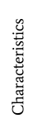

- ISM | Romanticism | Realism | Modernism
