Okonkwo as Tragic Hero in Achebe’s Things Fall Apart
Important Definitions:
- Tragedy = of an action that is and of a certain (according to Aristotle.)
- Tragic hero = of story who makes a that inevitably leads to his/her own . Has a (hamartia) that leads to downfall. Oftentimes, this flaw is a sort of excessive (hubris).
Purpose of tragedy: to create in the audience, leading to a (catharsis).

There are 3 main types of tragic hero. Some basic elements of each:
- _________________________
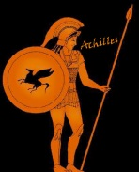
- ____________, or high stature. Heroic or potentially heroic qualities.
- Fated by the Gods or supernatural force to doom or at least to great suffering. Reversal of fortune.
- Challenges fate. Belief in own freedom wins our admiration, despite pending doom.
- Tragic flaw = often resisting fate i.e. ____________.
- Harsh punishment = death (not always)
- Public mourning
- _________________________
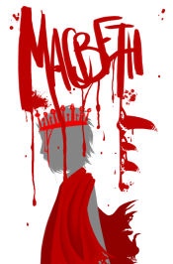
- Noble birth, or high stature. Has potential for greatness = his/her tragedy will have far-reaching effects.
- A good person, but _______________
- Makes serious errors in judgment, including misreading of situations.
- ___________ and isolates self
- Recognizes mistakes/flaw too late, so tries to at least die bravely.
- Tragic flaw
- Harsh punishment = death
- Public mourning
- _________________________
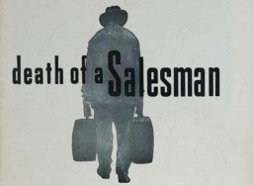
- __________ may be oppressor
- Does not have to be high born. ______________
- May/not result in recognition of tragic flaw
- Harsh Punishment: May/not die
- May/not be mourned

Complete the following chart to show evidence of Okonkwo as a tragic hero. Use specific examples.
Tragic Hero Defining quality | Okonkwo Details
A person whose fate matters to a nation or people.

Challenges Fate - struggles against supernatural forces or doom.

Has a tragic flaw (hamartia), a personality flaw, or is unable to accept a diminished view of the self.
Examples:
    - Pride (hubris)
    - Vanity
    - Over confidence
    - Arrogance
    - Cowardice…
Fails errors in judgment bring about destruction and/or Fate or accident prevent success.

Develops deeper self-knowledge; -through suffering becomes enlightened.

Does anyone mourn him?

Is Okonkwo a tragic hero? If so, does he fit any particular category? Explain.

