Character | Archetype 1 | Archetype 2 | Explanation
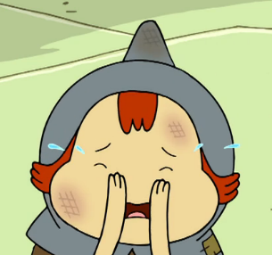

Situation Archetypes:

Motif Archetypes:

What archetypes can we see in Bless Me, Ultima?

Write a thesis that would answer the question: What role does water play as an archetype in Bless Me, Ultima?

