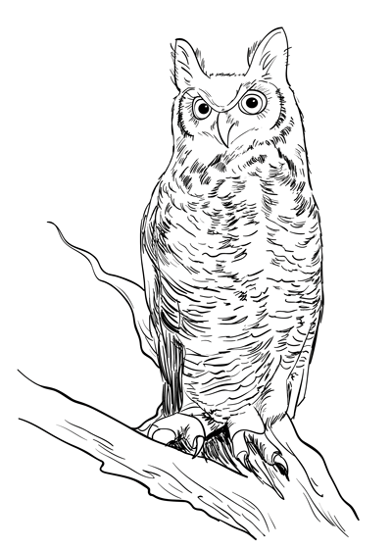
Bless Me, Ultima – Unit Calendar
Calendar is subject to change. Reading quizzes may be given without notice. Arrive ready to discuss the chapter.
Week 10 | 10.1 | 10.2 | 10.3 | 10.4 | 10.5
12-16 Nov | Veterans Day | Uno+Dos | Tres | Cuatro+Cinco | Seis+Siete
Week 11 | 11.1 | 11.2 | 11.3 | 11.4 | 11.5
19-23 Nov | Ocho+Nueve | Diez | Once | Thanksgiving | Thanksgiving
Week 12 | 12.1 | 12.3 | 12.3 | 12.4 | 12.5
26-30 Nov | Doce+Trece | Catorce | Quince | Dieciseis  Diecisiete | Dieceocho  Diecinueve
Week 13 | 13.1 | 13.2 | 13.3 | 13.4 | 13.5
3-7 Dec | Viente  Vienteuno | Vientedos  Prompts | Thesis Work Time | Thesis Due 8am  Evidence Lesson | Organization Lesson  Work Day
Week 14 | 14.1 | 14.2 | 14.3 | 14.4 | 14.5
10-14 Dec | Analysis Lesson  Work Day | Outline Due 8am | BMU Test | Work Day | MLA Lesson  Lang. Lesson
Week 15 | 15.1 | 15.2 | 15.3 | 15.4 | 15.5
17-19 Dec | Rough Draft  Due 8a  Paper Copy Due  Peer Edit In Class | Work Day | Final Draft Due 8am  BMU Packet Due In Class | Winter Break | Winter Break

Bless Me, Ultima – Unit Calendar
Week 10 | 10.1 | 10.2 | 10.3 | 10.4 | 10.5
12-16 Nov | Veterans Day | Uno+Dos | Tres | Cuatro+Cinco | Seis+Siete
Week 11 | 11.1 | 11.2 | 11.3 | 11.4 | 11.5
19-23 Nov | Ocho+Nueve | Diez | Once | Thanksgiving | Thanksgiving
Week 12 | 12.1 | 12.3 | 12.3 | 12.4 | 12.5
26-30 Nov | Doce+Trece | Catorce | Quince | Dieciseis  Diecisiete | Dieceocho  Diecinueve
Week 13 | 13.1 | 13.2 | 13.3 | 13.4 | 13.5
3-7 Dec | Viente  Vienteuno | Vientedos  Prompts | Thesis Work Time | Thesis Due 8am  Evidence Lesson | Organization Lesson  Work Day
Week 14 | 14.1 | 14.2 | 14.3 | 14.4 | 14.5
10-14 Dec | Analysis Lesson  Work Day | Outline Due 8am | BMU Test | Work Day | MLA Lesson  Lang. Lesson
Week 15 | 15.1 | 15.2 | 15.3 | 15.4 | 15.5
17-19 Dec | Rough Draft  Due 8a  Paper Copy Due  Peer Edit In Class | Work Day | Final Draft Due 8am  BMU Packet Due In Class | Winter Break | Winter Break
Calendar is subject to change. Reading quizzes may be given without notice. Arrive ready to discuss the chapter.

