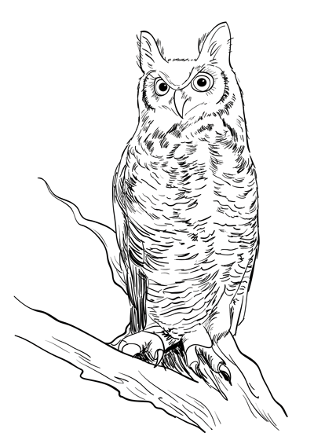
Bless Me, Ultima – Essay Calendar
Week 13 | 13.1 | 13.2 | 13.3 | 13.4 | 13.5
3-7 Dec | Viente  Vienteuno | Vientedos | Prompts  Calendar | Thesis Work Time | Thesis due 8am  Evidence Lesson
Week 14 | 14.1 | 14.2 | 14.3 | 14.4 | 14.5
10-14 Dec | Org. Lesson | Analysis Lesson | Outline due 8am  BMU Test | Work Day | Intro/Conclu Lesson  Work Day
Week 15 | 15.1 | 15.2 | 15.3 | 15.4 | 15.5
17-19 Dec | MLA Lesson  Lang lesson | Rough Draft due 8am  Paper copy due  Peer Edit | BMU Packets Due in Class  Work Day | Winter Break | Winter Break
Final draft of the BMU essay is due 8am Thursday, January 3rd to Turnitin.com. You must also bring a printed copy of your essay.

Sign up for conferences on Ms. Gilpin’s door, 2409. All major due dates refer to Turnitin.com assignments.

Essay Prompts
- Pick your own:
  - How does ____________ (literary device, technique, structure) affect the novel?
  - How does ____________ (literary device, technique, structure) create the ________________ (theme, purpose) of Bless Me, Ultima.
- How do the elements of magical realism shape Bless Me, Ultima?
- What does the Virgin of Guadalupe symbolize? How does this relate to gender stereotypes, Antonio’s parents, forgiveness and God?
- Analyze how Anaya characterizes Antonio using 1-3 method(s) of characterization—explain how this method shows Antonio’s change from start to finish of Bless Me, Ultima.
- What effect does Rudolfo Anaya’s juxtaposition of God with other religious idols/powers have on Bless Me, Ultima?
- Anaya is ambiguous about whether Ultima is a bruja. How does this affect the archetype she inhabits?
- How does Anaya comment on culture’s tendency to label women and curanderas as witches? What is the effect of the juxtaposition of Ultima’s powers with the church’s powers and/or the bruja’s powers?
- What is Rudolfo Anaya’s attitude (tone) or social commentary towards Catholicism/the church in Bless Me, Ultima? How does Antonio reveal or hide these opinions?

Essay Requirements:
  - MLA formatted
    - Typed (12-point, Times New Roman font; double-spaced; 1-inch margins)
    - In-text parenthetical citations
    - Works Cited page
  - Length: 700-900 words NOT including the Works Cited page or headings
      - Percentage penalty if you are over or under
  - Third-person point-of-view only (absolutely no you, your, I, me, my, we, etc.)
  - Formal, argumentative style (absolutely no slang or contractions)
  - Thesis, outline, rough draft and final draft submitted to www.turnitin.com
  - Your essay will follow one of these outlines:
- Intro paragraph  - Hook  - Context  - Thesis statement [MUST be last]  - Body Paragraph topic 1  - Evidence and analysis  - Evidence and analysis  - Body paragraph topic 2  - Evidence and analysis  - Evidence and analysis  - Body paragraph topic 3  - Evidence and analysis  - Evidence and analysis  - Conclusion  - Restate thesis statement in a new way  - Context  - Universal idea | - Intro paragraph  - Hook  - Context  - Thesis statement [MUST be last]  - Body Paragraph topic 1  - Evidence and analysis  - Evidence and analysis  - Evidence and analysis  - Body paragraph topic 2  - Evidence and analysis  - Evidence and analysis  - Evidence and analysis  - Conclusion  - Restate thesis statement in a new way  - Context  - Universal idea

Note:
  - Make sure you have all your essay docs (thesis, outline, drafts) with you every day via Google docs, USB drive, etc.
  - Late drafts will be -25% and will have delayed feedback.
  - Late final drafts will receive -10% credit per 24 hours late.
  - This essay will be scored for both Social Studies and Language Arts.
  - Rubric attached
The Writing Process:
- Your BMU packet worksheets and journals
- Consider prompts
- Create a thesis statement
- Organize your evidence in an outline
- Create a rough draft from your outline
- Edit, revise, proofread – including a peer proofread
- Create a final draft

