 | M | T | W | T | F
Week 24 | 24.1 | 24.2 | 24.3 | 24.4 | 24.5
Mar 2-6 | Check out books  African Civ Quiz | Ch 1 | Ch 2 | Ch 3-4 | Ch 5-6  Igbo Project Due & Presentation
Week 25 | 25.1 | 5.2 | 25.3 | 25.4 | 25.5
Mar 9-13 | Ch 7-8 | Ch 9 | Ch 10-11 | Ch 12-13 | Test  TFA Part 1 +  SS Content
Week 26 | 26.1 | 26.2 | 26.3 | 26.4 | 26.5
Mar 16-20 | Ch 14-15 | Ch 16-17 | Ch 18-19 | Ch 20-21 | Test  TFA Part 2 +  SS Content
Week 27 | 27.1 | 27.2 | 27.3 | 27.4 | 27.5
Mar 23-27 | Ch 22-23 | Ch 24-25 | Test  TFA Part 3 +  Short Essay | Essay | TFA Packet Due  Essay
Week 28 | 28.1 | 28.2 | 28.3 | 28.4 | 28.5
Mar 31-Apr 3 | Essay | Essay | Essay | Essay | Essay
Week 29 | 29.1 | 29.2 | 29.3 | 29.4 | 29.5
Apr 6-10 | Essay | Essay | Essay | Essay | Essay
You must arrive at class having read, and ready to discuss, the chapters for that day.
Calendar is subject to change. Essay due dates will be given when we start writing.
Final draft of the essay will be due Friday, April 10th.
1: Calendar and table of contents
2: Igbo Language Glossary
3-6: Vocabulary
7-8: Igbo Culture Notes
9-10: Primary Source Document 1 – “White Man’s Burden”
11-12: Primary Source Document 2 – “Black Man’s Burden”
13-14: Things Fall Apart Character Map
15: OPCVL Template
Completed packet is due Friday, March 27th. We may require that some portions of the packet be done by a specific date to earn an “on-time” stamp and avoid a partial late penalty.
glossary, noun: a list of terms or words found in or relating to a specific subject, text, or dialect, with explanations; a brief dictionary.
As you read, create your own glossary: record Igbo words you learn and a brief definition to help you keep track. Space is provided for 20 terms; 15 are required. Check your spelling carefully.

Term | Part of Speech | Definition | Explain how the term connects to Africa or TFA
imperialism
colonialism
ideology
primitive
civilized
Social Darwinism
stereotype
assimilate
colony
missionary
proselytize
protectorate
annex
paternalistic
exploit
Eurocentric
genocide
humanitarian
tribe
nation

 | Notes
Igbo Spiritual Belief | - Role of ancestors and spirits  - Supreme God  - Concept of chi  - Beliefs regarding death
Igbo Events & Celebration | - What/when is the yam festival?  - What does the yam symbolize?  - Why is yam important?  - What is the kola nut?  - How is the kola nut used?  - Igbo Weddings
Igbo History | - Location of tribe  - Approximate date of origin  - First contact with Europeans. Why?  - Effect of imperialism on tribe  - Goods traded  - Relationship with Europeans
Igbo Cultural Details | - Dress  - Language  - Village life/leadership  - Role of women  - Political system
Chinua Achebe | - Full name  - Background: birth date, location, parents, family life  - Significance  - Literary language  - Goals  - Achievements
- 1
Rudyard Kipling, “The White Man’s Burden” 1899

The White Man’s Burden
By: Rudyard Kipling

Take up the White Man's burden--
Send forth the best ye breed--
Go bind your sons to exile
To serve your captives' need;
To wait in heavy harness,
On fluttered folk and wild--
Your new-caught, sullen peoples,
Half-devil and half-child.

Take up the White Man's burden--
In patience to abide,
To veil the threat of terror
And check the show of pride;
By open speech and simple,
An hundred times made plain
To seek another's profit,
And work another's gain.

Take up the White Man's burden--
The savage wars of peace--
Fill full the mouth of Famine
And bid the sickness cease;
And when your goal is nearest
The end for others sought,
Watch sloth and heathen Folly
Bring all your hopes to nought.

Take up the White Man's burden--
No tawdry rule of kings,
But toil of serf and sweeper--
The tale of common things.
The ports ye shall not enter,
The roads ye shall not tread,
Go mark them with your living,
And mark them with your dead.

Take up the White Man's burden--
And reap his old reward:
The blame of those ye better,
The hate of those ye guard--
The cry of hosts ye humour
(Ah, slowly!) toward the light:--
"Why brought he us from bondage,
Our loved Egyptian night?"

Take up the White Man's burden--
Ye dare not stoop to less--
Nor call too loud on Freedom
To cloke your weariness;
By all ye cry or whisper,
By all ye leave or do,
The silent, sullen peoples
Shall weigh your gods and you.

Take up the White Man's burden--
Have done with childish days--
The lightly proferred laurel,
The easy, ungrudged praise.
Comes now, to search your manhood
Through all the thankless years
Cold, edged with dear-bought wisdom,
The judgment of your peers!

Source: Rudyard Kipling, “The White Man’s Burden: The United States & The Philippine Islands, 1899.” Rudyard Kipling’s Verse: Definitive Edition (Garden City, New York: Doubleday, 1929).
- 2
Edward D. Morel, The Black Man’s Burden (1903)

Edward Morel (1873-1924) was a French-born British journalist and socialist who drew attention to imperial abuses and led a campaign against slavery in the Belgian Congo. While working for a Liverpool shipping firm in Brussels, Morel noticed that the ships leaving Belgium for the Congo carried only guns, chains, and ammunition, but no commercial goods, and that ships arriving from the colony came back full of valuable products such as rubber and ivory, which led him to surmise that Belgian King Leopold II's colony was exploitative and relied on slave labor. Morel wrote The Black Man’s Burden (1920), from which the following excerpt is taken, as a response to Rudyard Kipling’s poem, “The White Man’s Burden.”

It is [the Africans] who carry the “Black man’s burden.”

In hewing out for himself a fixed abode in Africa, the white man has massacred the African in heaps. The African has survived, and it is well for the white settlers that he has.

In the process of imposing his political dominion over the African, the white man has carved broad and bloody avenues from one end of Africa to the other. The African has resisted, and persisted.

For three centuries the white man seized and enslaved millions of Africans and transported them, with every circumstance of ferocious cruelty, across the seas. Still the African survived and, in his land of exile, multiplied exceedingly.

But what the partial occupation of his soil by the white man has failed to do; what the mapping out of European political “spheres of influence” has failed to do; what the Maxim and the rifle, the slave gang, labor in the bowels of the earth and the lash, have failed to do; what imported measles, smallpox and syphilis have failed to do; what even the oversea slave trade failed to do, the power of modern capitalistic exploitation, assisted by modern engines of destruction, may yet succeed in accomplishing.

For from the evils of the latter, scientifically applied and enforced, there is no escape for the African. Its destructive effects are not spasmodic: they are permanent. In its permanence resides its fatal consequences. It kills not the body merely, but the soul. It breaks the spirit. It attacks the African at every turn, from every point of vantage. It wrecks his polity, uproots him from the land, invades his family life, destroys his natural pursuits and occupations, claims his whole time, enslaves him in his own home…

The African of the tropics is capable of tremendous physical labors. But he cannot accommodate himself to the European system of monotonous, uninterrupted labor, with its long and regular hours, involving, moreover, as it frequently does, severance from natural surroundings and nostalgia, the condition of melancholy resulting from separation from home, a malady to which the African is especially prone. Climatic conditions forbid it. When the system is forced upon him, the tropical African droops and dies.

Nor is violent physical opposition to abuse and injustice henceforth possible for the African in any part of Africa. His chances of effective resistance have been steadily dwindling with the increasing perfectibility in the killing power of modern armament… Thus the African is really helpless against the material gods of the white man, as embodied in the trinity of imperialism, capitalistic-exploitation, and militarism. If the white man retains these gods and if he insists upon making the African worship them as assiduously as he has done himself, the African will go the way of the… Amerindian, …the aboriginal Australian, and many more. And this would be at once a crime of enormous magnitude, and a world disaster…

To reduce all the varied and picturesque and stimulating episodes in savage life to a dull routine of endless toil for uncomprehended ends, to dislocate social ties and disrupt social institutions; to stifle nascent desires and crush mental development; to graft upon primate passions the annihilating evils of scientific slavery, and the bestial imaginings of civilized man, unrestrained by convention or law; …to kill the soul in a people – this is a crime which transcends physical murder…

It is often argued that the agricultural… methods of the African are capable of improvement. The statement is undoubtedly true. It applies with equal force to the land of Britain…Why, it is only since the beginning of the 18th century that the rotation of crops has been practiced in England! But the Kano farmers in Northern Nigeria have understood rotation of crops and grass manuring for at least five hundred years. To advance such truisms as an excuse for robbing the native communities of their land, degrading farmers in their own right to the level of hired laborers urged on by the lash, and conferring monopolistic rights over the land and its fruits to private corporations, is to make truth the stalking horse of oppression and injustice. The statement of fact may be accurate. The claim put forward on the strength of it is purely predatory.

Those who urge this and kindred arguments only do so to assist the realization of their purpose. That purpose is clear. It is to make of Africans all over Africa a servile race; to exploit African labor, and through African labor, the soil of Africa for their own exclusive benefit…

For a time it may be possible for the white man to maintain a white civilization in the colonizable, or partly colonizable, areas of the African Continent based on servile or semi-servile labor: to build up a servile State. But even there the attempt can be no more than fleeting. The days of Roman imperialism are done with forever. Education sooner or later breaks all chains, and knowledge cannot be kept from the African… [When] he becomes alive to his power the whole fabric of European domination will fall to pieces in shame and ruin. From these failures the people of Europe will suffer moral and material damage of a far-reaching kind…

Why cannot the white imperial peoples, acknowledging in some measure the injuries they have inflicted upon the African, turn a new leaf in their treatment of him? For nearly two thousand years they have professed to be governed by the teachings of Christ. Can they not begin in the closing century of that era, to practice what they profess – and what their missionaries of religion teach the African? Can they not cease to regard the African as a producer of dividends for a selected few among their number, and begin to regard him as a human being with human rights?

Source: E. D. Morel, The Black Man's Burden, in Louis L. Snyder, The Imperialism Reader (Princeton, N.J.: Van Nostrand, 1962), pp.l63_l64. First published in 1920 in Great Britain.
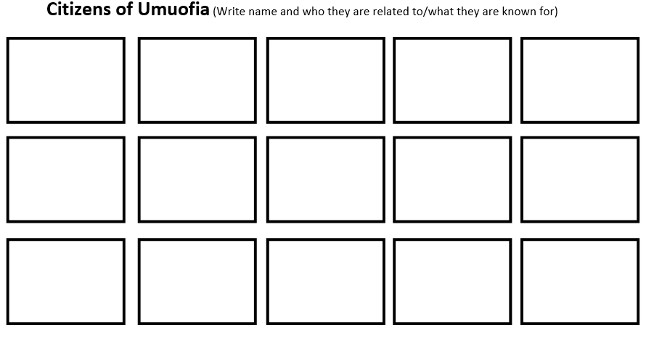
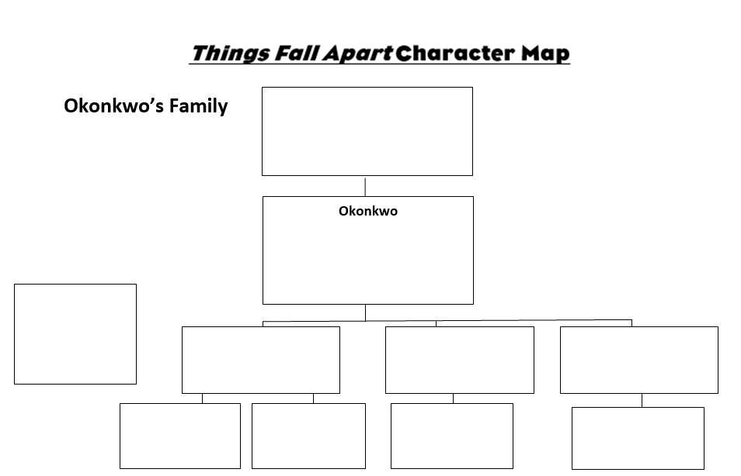
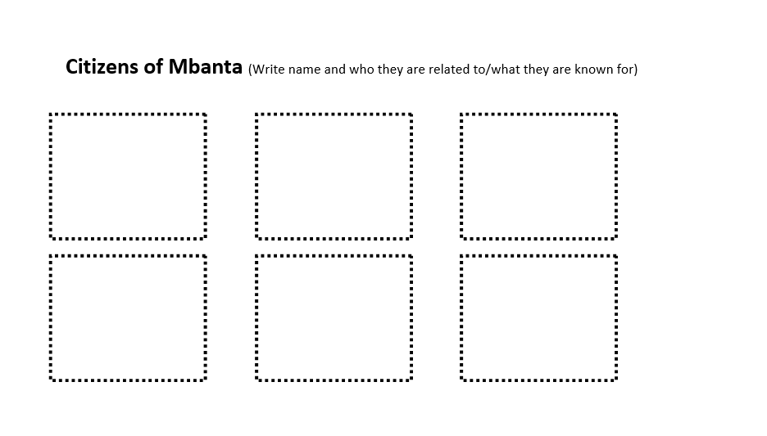
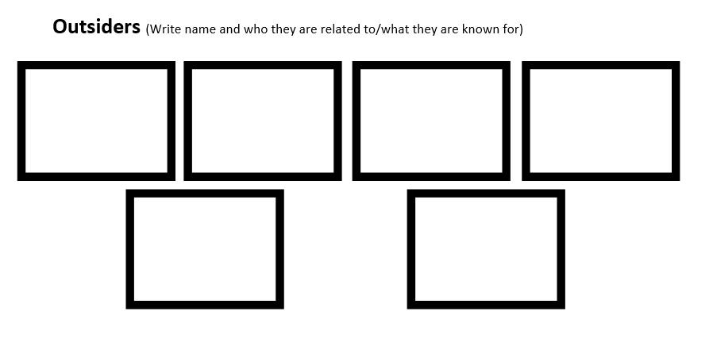
OPCVL | Values | Limitations
Origin
Purpose
Content/ Context

