HOW TO FORMAT A POLITICAL CARTOON CITATION IN MLA

Artist's Last Name, First Name. "Title if Any." Publication Name, date of publication, page number or URL if online.

Example #1 (political cartoon retrieved in print):
Block, Herbert. "The American Scene." New York Times, 1 Feb. 1942, E3.

Example #2 (political cartoon retrieved from a website):
Block, Herbert. "What's This About Your Letting the Common People Come in Here and Read Books?" Washington Post, 6 June 1954. Library of Congress. www.loc.gov/exhibits/herblock/classic-cartoons-by-a-master.html#obj2. Accessed 6 Aug. 2018.
---------------
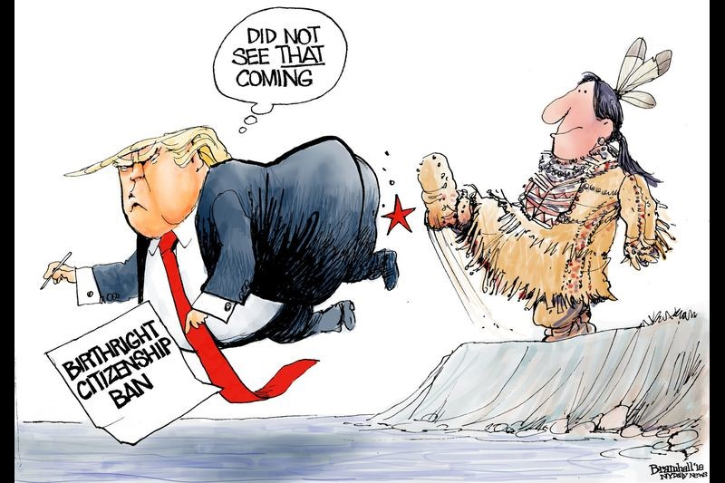
Author: Bill Bramhall
Title: (none)
Publication name: New York Daily News
Date: 2018
URL: https://twitter.com/billbramhall
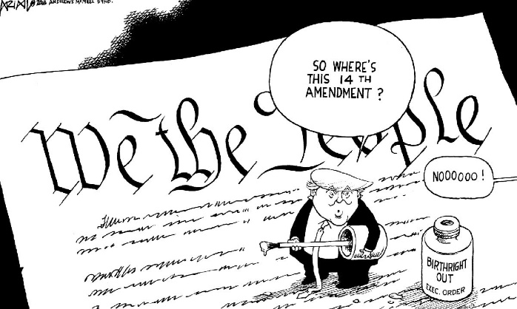Author: Robert Ariail
Title: (none)
Publication name: The State
Date: 2018
URL: https://www.thestate.com/opinion/editorial-cartoons/robert-ariail/
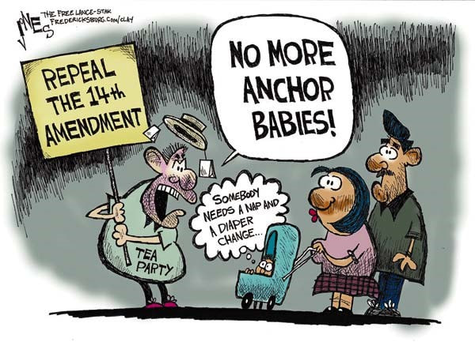
Author: Clay Jones
Title: (none)
Publication name: The Free Lance-Star
Date: 2018
URL: (none)
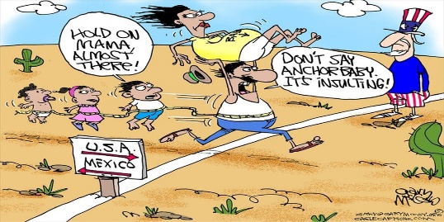
Author: Gary McCoy
Title: (none)
Publication name: Cagle Cartoons
Date: 08/31/15
URL: https://www.cagle.com/tag/birthright-citizenship/
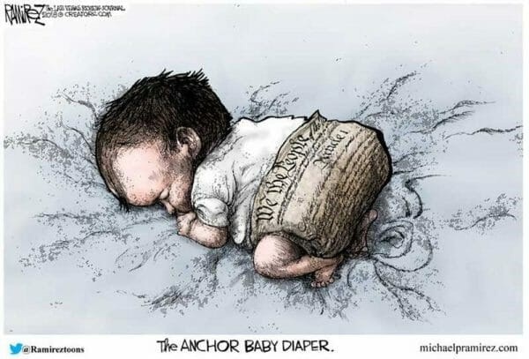
Author: Michael P. Ramirez
Title: The Anchor Baby Diaper
Publication name: Michaelpramirez.com
Date: 2018
URL: michaelpramirez.com
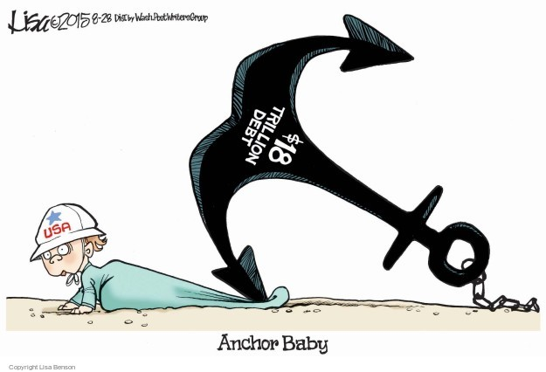
Author: Lisa Benson
Title: (none)
Date: 2015-08-28
Publication name: Lisa Benson's Editorial Cartoons
URL: http://www.theeditorialcartoons.com/subject/The-Anchor+Baby-Editorial-Cartoons.php
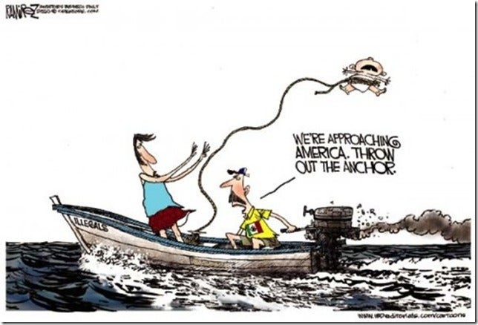
Author: Michael P. Ramirez
Title: (none)
Date: (none)
Publication name: IDB Editorials
URL: www.idbeditorials.com/cartoons
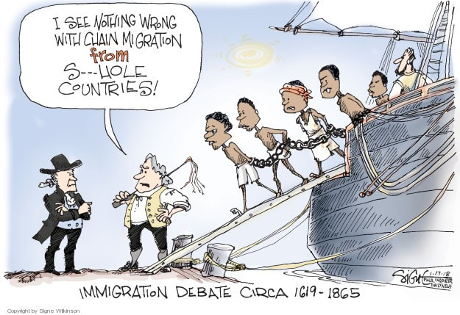
Author: Signe Wilkinson
Title: Immigration Debate Circa 1619-1865
Date: 1/17/18
Publication name: IDB Editorials
URL: https://www.realclearpolitics.com/cartoons/2018/01/16/signe_wilkinson_current_cartoon_2018-01-17.html

