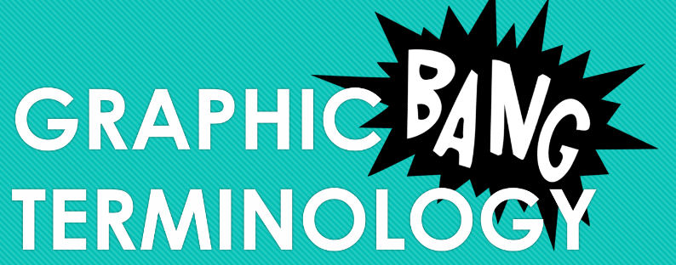
Note Sheet
Name:
Class/#:

Intro Questions
- __________________________________________________________________________________________________________________________________________________________________________________
- __________________________________________________________________________________________________________________________________________________________________________________
- __________________________________________________________________________________________________________________________________________________________________________________

General terms (2):

Panel and related terms (4):

Speech and symbols (4):
Graphic Weight (1):

Placement inside panels (3):

Transitions (6):

