Creating Seminar Questions
Your Socratic Seminar will provide you with guiding questions to focus your discussion. However, an important Seminar skill is to continue conversation by asking your peers questions that deepen and continue the conversation.
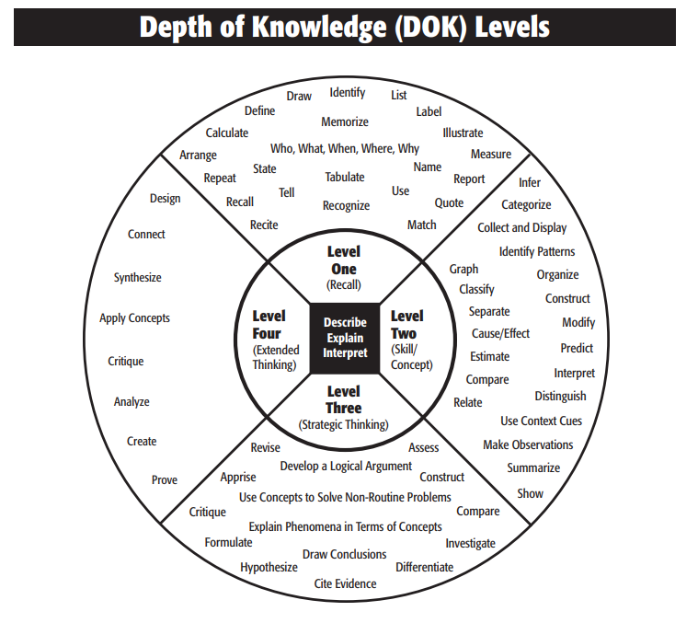
Use the chart above to identify which Level each questions belongs to.
What is Marji’s uncle’s name? _______Level______________
Create your own graphic novel that shares themes with Persepolis. __________________________
Look at the panel of Marji’s mother protesting on page 15. How is she feeling in this panel? ______________________
How does the Iranian Revolution affect Marji’s personal philosophy? __________________________
Write a book review of Persepolis, focusing on its effectiveness at teaching a lesson. __________________________

Which level(s) are most helpful in a Socratic Seminar? Explain your reasoning. __________________________________
__________________________________________________________________________________________________
__________________________________________________________________________________________________
Create 5 Level One Questions for Persepolis Parts 1-3. Do not answer them.
1._________________________________________________________________________________________________
__________________________________________________________________________________________________
2._________________________________________________________________________________________________
__________________________________________________________________________________________________
3._________________________________________________________________________________________________
__________________________________________________________________________________________________
4._________________________________________________________________________________________________
__________________________________________________________________________________________________
5._________________________________________________________________________________________________
__________________________________________________________________________________________________
Create 3 Level Two Questions for Persepolis Parts 1-3. Do not answer them.
1._________________________________________________________________________________________________
__________________________________________________________________________________________________
2._________________________________________________________________________________________________
__________________________________________________________________________________________________
3._________________________________________________________________________________________________
__________________________________________________________________________________________________
Create 2 Level Three Questions for Persepolis Parts 1-3. Do not answer them.
1._________________________________________________________________________________________________
__________________________________________________________________________________________________
2._________________________________________________________________________________________________
__________________________________________________________________________________________________

