Persepolis - Creating Captions Through Inference
- “Read” the following graphics from Persepolis
- Use your knowledge of facial expression, hand/feet gestures, and graphic weight to infer what the image is attempting to communicate
- Write a caption for each image
- Justify your caption using your knowledge of facial expression, hand/feet gestures, and graphic weight
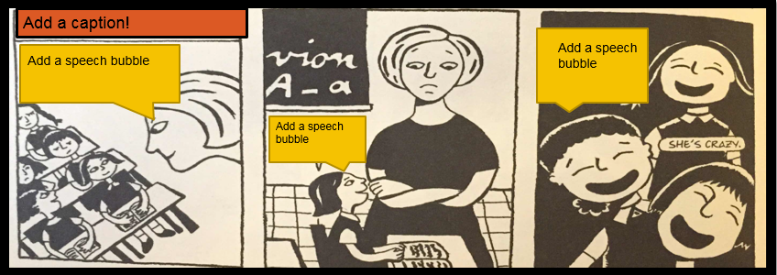

Justification: _______________________________________________________________________________________
__________________________________________________________________________________________________
__________________________________________________________________________________________________
__________________________________________________________________________________________________
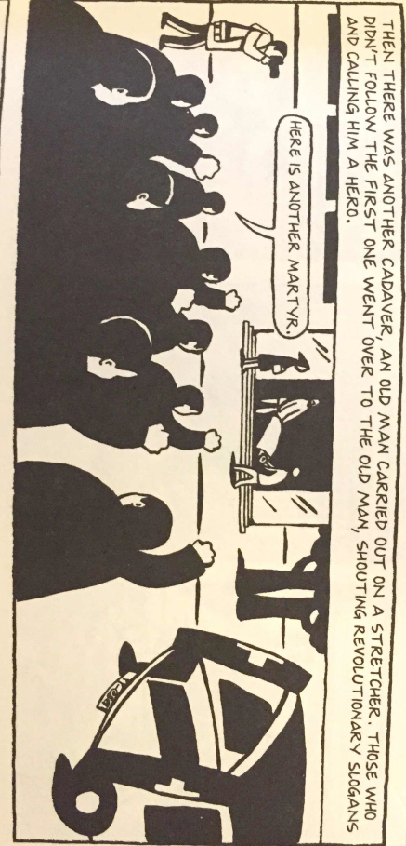

Justification: _______________________________________________________________________________________
__________________________________________________________________________________________________
__________________________________________________________________________________________________
__________________________________________________________________________________________________

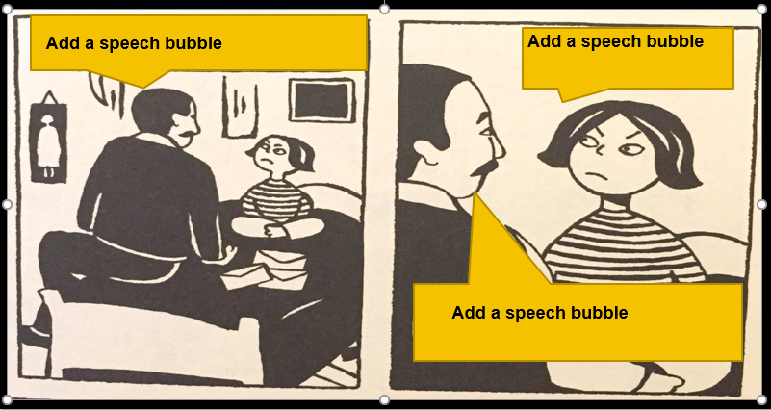

Justification: _______________________________________________________________________________________
__________________________________________________________________________________________________
__________________________________________________________________________________________________
__________________________________________________________________________________________________
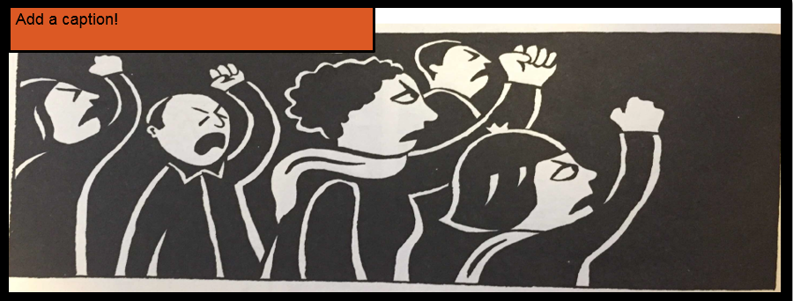
Justification: _______________________________________________________________________________________
__________________________________________________________________________________________________
__________________________________________________________________________________________________
__________________________________________________________________________________________________
- What can you infer about the plot of Persepolis (from the excerpts we saw & discussed)?
__________________________________________________________________________________________________
__________________________________________________________________________________________________
__________________________________________________________________________________________________
- What tone do you anticipate will pervade the text? Why?
__________________________________________________________________________________________________
__________________________________________________________________________________________________
__________________________________________________________________________________________________

